Elton, Gruber, Brown, and Goetzmann
Modern Portfolio Theory and Investment Analysis, 9th Edition
Solutions to Text Problems: Chapter 11

Chapter 11: Problem 1

Expected utility of investment A = 1/3 × −7.5 + 1/3 × −12.5 + 1/3 × −31.5 = −17.0

Expected utility of investment B = 1/4 × −4.0 + 1/2 × −17.5 + 1/4 × −40.0 = −19.75

Expected utility of investment C = 1/5 × 0.5 + 3/5 × −31.5 + 1/5 × −144.0 = −47.8

Investment A is preferred because it has the highest level of expected utility.

Chapter 11: Problem 2

Expected utility of investment A = 1/3 × −0.45 + 1/3 × −0.41 + 1/3 × −0.33 = −0.40

Expected utility of investment B = 1/4 × −0.50 + 1/2 × −0.38 + 1/4 × −0.32 = −0.39

Expected utility of investment C = 1/5 × −1 + 3/5 × −0.33 + 1/5 × −0.24 = −0.45

Investment B is preferred because it has the highest level of expected utility.

Chapter 11: Problem 3

Expected utility of investment A = 2/5 × −8.96 + 1/5 × −14 + 2/5 × −21.84 = −15.12

Expected utility of investment B = 1/2 × −6 + 1/4 × −17.76 + 1/4 × −36 = −16.44

Investment A is preferred because it has the highest level of expected utility.

Chapter 11: Problem 4

For an investor to be indifferent, the expected utility of investment B must be set equal to that of investment A. Referring back to Problem 3, we see that the given probabilities are for the first two of the three outcomes in investment B. So we need to solve for the probabilities of those two outcomes that make investment B’s expected utility level equal to that of A’s. Since the last outcome in investment B has a probability of 1/4, the first two probabilities must sum to 3/4. Therefore we have:
X × −6 + (3/4 −X) × −17.76 + 1/4 × −36 = −15.12
Solving for X:
X = 0.61

Therefore, the first outcome’s probability of 0.5 would have to be increased by 0.11 to 0.61, and the second outcome’s probability of 0.25 would have to be reduced by 0.11 to 0.14.

Chapter 11: Problem 5

The investor will prefer the investment that maximizes expected utility of terminal wealth. Recall that the formula for expected utility of wealth (E[U(W)]) is:

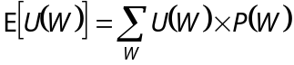

where each P(W) is the probability associated with each particular outcome of wealth (W). Since 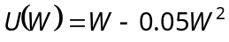, we have:

Investment A:

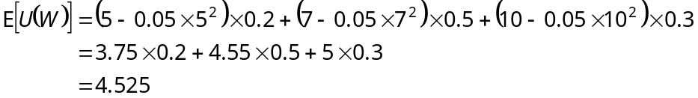

Investment B:
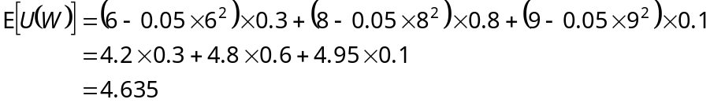

Investment B is preferred over investment A since B provides higher expected utility.

Chapter 11: Problem 6

To solve this problem, set the expected utility of investment A in Problem 5 equal to 4.635 (the expected utility of investment B) and solve for the value of the first outcome in investment A:

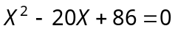
The equation above is a quadratic equation with two roots. Using the quadratic formula, the roots are found to be 6.26 and 13.74. So, the minimum amount that the first outcome of investment A would have to change by for the investor to be indifferent between investments A and B would be $6.26 − $5 = $1.26 (an increase), since both investments would then provide the same level of expected utility.

Chapter 11: Problem 7

Roy’s safety-first criterion is to minimize Prob(R_{P} < R_{L}). If R_{L} = 5%, then (assuming an initial investment of $100) for the outcomes in Problem 1 we have:
Prob(R_{A} < 5%) = 0.0

Prob(R_{B} < 5%) = 0.25

Prob(R_{C} < 5%) = 0.20

Thus, using Roy’s safety-first criterion, investment in A is preferred over investments in B and C, and investment in C is preferred over investment in B.

Chapter 11: Problem 8

Kataoka's safety-first criterion is to maximize R_{L} subject to Prob(R_{P} < R_{L}) α. If α = 10%, then (assuming an initial investment of $100) for the outcomes in Problem 1 the maximum R_{L} is:

4.99% for A

3.99% for B

0.99% for C

Thus, A is preferred to B and C, and B is preferred to C.

Chapter 11: Problem 9

Employing Telser's criterion, we see that (assuming an initial investment of $100) Projects A, B and C in Problem 1 do not satisfy the constraint Prob(R_{p} 5%) 10%. So, investments A, B, and C are indistinguishable using Telser’s criterion with R_{L} = 5%.

Chapter 11: Problem 10

The geometric mean returns of the outcomes shown in Problem 1 (assuming an initial investment of $100) are:

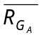 = (1.05)^{1/3} (1.06)^{1/3} (1.09)^{1/3} − 1 = 0.0665 (6.65%)

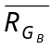 = (1.04)^{1/4} (1.07)^{1/2} (1.1)^{1/4} − 1 = 0.0698 (6.98%)

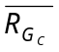 = (1.01)^{1/5} (1.09)^{3/5} (1.18)^{1/5} − 1 = 0.0907 (9.07%).

Thus, C > B > A.

Chapter 11: Problem 11

Roy's criterion is to minimize Prob(R_{P} < R_{L}). When R_{L} = 3%, Prob(R_{A} < 3%) = 0,
Prob(R_{B} < 3%) = 0, and Prob(R_{C} < 3%) = 0. So, investments A, B, and C are indistinguishable using Roy's criterion with R_{L} = 3%.

Chapter 11: Problem 12

The geometric mean returns of the investments shown in Problem 11 are:

= (1.03)^{.4} (1.04)^{.3} (1.06)^{.1} (1.07)^{.1} (1.09)^{.1} − 1 = 0.0458 (4.58%)

= (1.05)^{.1} (1.06)^{.2} (1.08)^{.1} (1.09)^{.2} (1.1)^{.4} − 1 = 0.0828 (8.28%)

= (1.05)^{.1} (1.07)^{.1} (1.08)^{.2} (1.09)^{.2} (1.11)^{.4} − 1 = 0.0898 (8.98%).

Thus, C > B > A.

